**Question 1**

i.

a)

|  |  |  |  |  |  |  |
| --- | --- | --- | --- | --- | --- | --- |
| 0 | 1 | 2 | 3 | 4 | 5 | 6 |
|  | 8 | 9 | 1 | 2 |  | 6 |

b)

|  |  |  |  |  |  |  |
| --- | --- | --- | --- | --- | --- | --- |
| 0 | 1 | 2 | 3 | 4 | 5 | 6 |
|  | 8 | 9 | 2 |  | 1 | 6 |

c)

|  |  |  |  |  |  |  |
| --- | --- | --- | --- | --- | --- | --- |
| 0 | 1 | 2 | 3 | 4 | 5 | 6 |
|  | 8 | 9 | 2 | 1 |  | 6 |

ii.

a) Probe 2, probe 3, probe 4 - FOUND

b) Probe 2, probe 3 - FOUND

c) Probe 2, Probe 3 - FOUND

iii.

a) Probe 5 - 1

b) Probe 5, Probe 6, Probe 2, Probe 0 - 4

c) Probe 5 - 1

**Question 2** a)

|  |  |  |  |
| --- | --- | --- | --- |
| **word** | **SHA1(word)** | **h1(word)** | **h(word)** |
| **I** | CA73AB65568CD125C2D27A22BBD9E863C10B675D | 93 | 5 |
| **AM** | 80D305C58F97EDFAE92A3627F5A66D9BEF4D8D46 | 70 | 4 |
| **SAM** | 64CD61B12116E058F5A31DEFEF2BC13DA3BDCB82 | 130 | 9 |
| **THAT** | 61A26854EE49839BBB7509F03BCB590FBC565738 | 56 | 1 |
| **SAM-I-AM** | 7439ABEAA4401A6A7B8B7C6B4A83CB2445E398EC | 236 | 5 |
| **DO** | 8FEB29077A1DF95BD8E261F267CF55119B1EAC74 | 116 | 6 |
| **NOT** | 969E7D8DEE132181523A501A068FEC75BDED3005 | 5 | 5 |
| **LIKE** | 5DDF6F04739D8BC3A11B487863B27A7BCAA6FC24 | 36 | 3 |

b)

|  |  |  |  |  |  |  |  |  |  |  |
| --- | --- | --- | --- | --- | --- | --- | --- | --- | --- | --- |
| 0 | 1 | 2 | 3 | 4 | 5 | 6 | 7 | 8 | 9 | 10 |
|  |  |  |  | AM  ↓  AM  ↓  AM | I  ↓  I  ↓  I | DO |  |  | SAM  ↓  SAM  ↓  SAM |  |

c)

|  |  |  |  |  |  |  |  |  |  |  |
| --- | --- | --- | --- | --- | --- | --- | --- | --- | --- | --- |
| 0 | 1 | 2 | 3 | 4 | 5 | 6 | 7 | 8 | 9 | 10 |
| THAT  ↓  THAT  ↓  THAT |  |  | LIKE | AM  ↓  AM  ↓  AM | I  ↓  I  ↓  I  ↓  SAM-I-AM  ↓  SAM-I-AM  ↓  I  ↓  NOT  ↓  SAM-I-AM |  |  |  | SAM  ↓  SAM  ↓  SAM |  |

**Question 3**

a)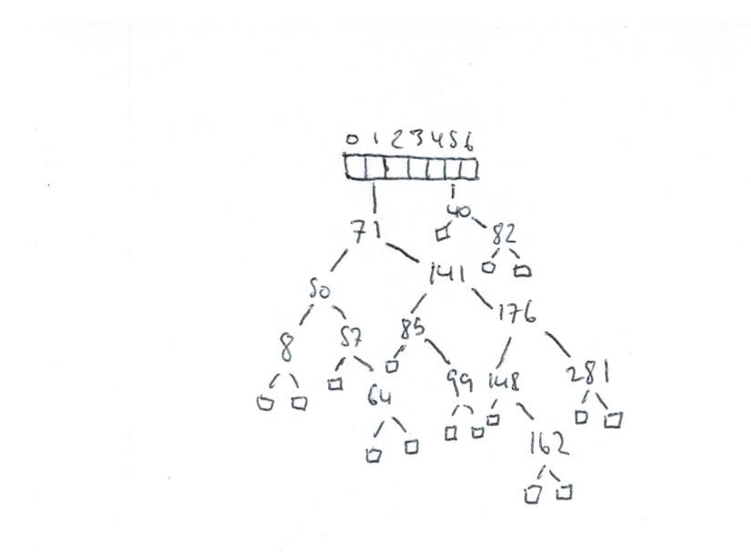

b)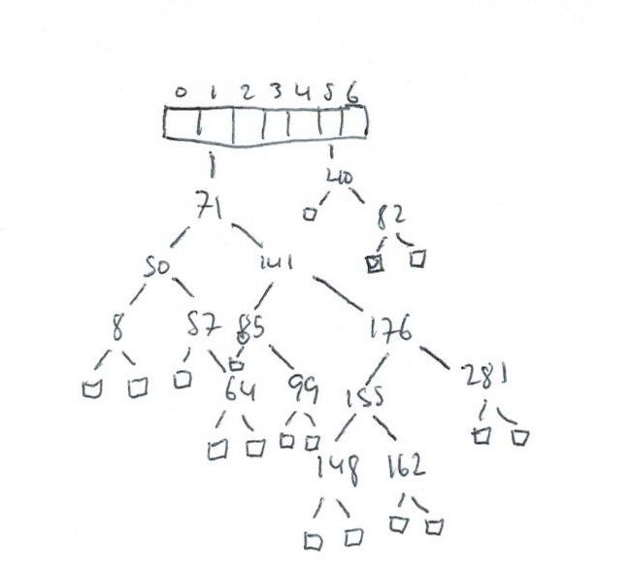

c) 1.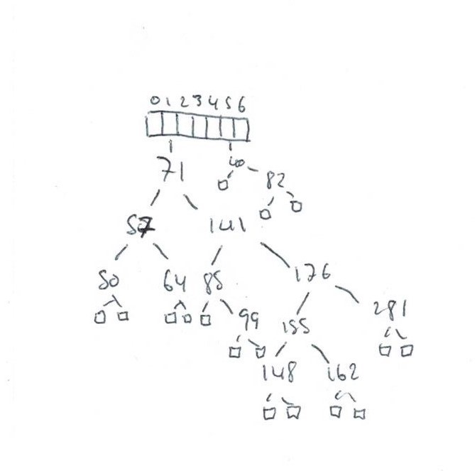

2.

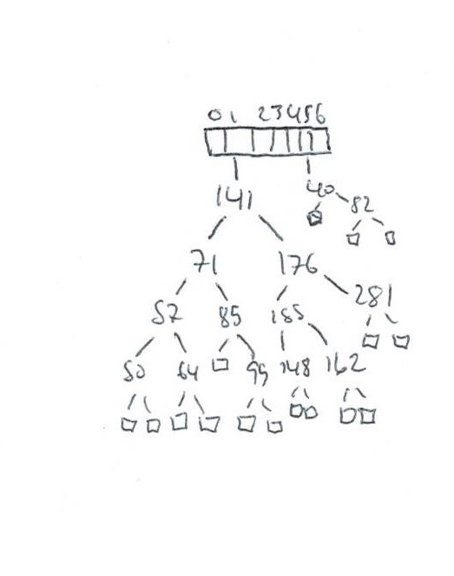

d)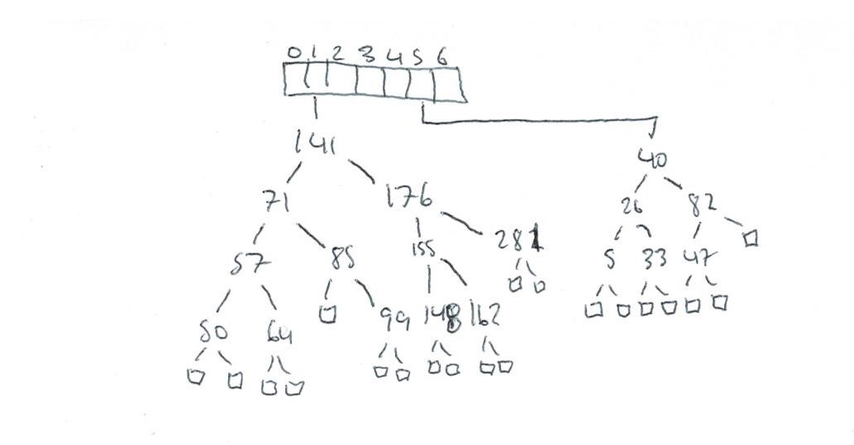

e)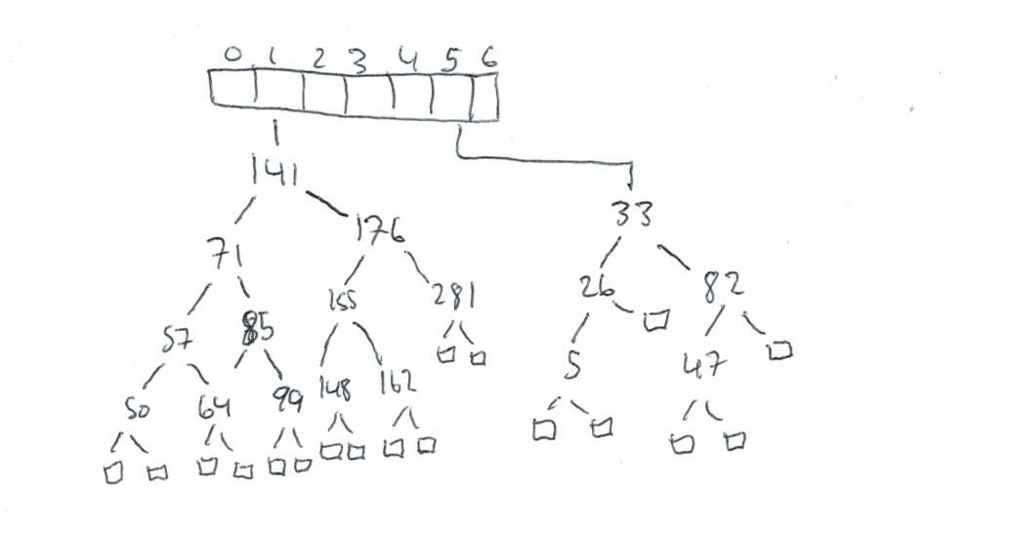

**Question 4**

A) ɑ = n/N = n/(4n/3) = n/4n * 3 = ¼ * 3 = ¾ = 0.75

B) O(n) because the values are in a list, worst case scenario is that the value is the last on the list, thus the program must read n/2 (the other half is in the other bucket) which is O(n)

C) O(log(n)) (base 2) because the values are in AVL trees, each time a value is read half the possibilities are removed (the right or left branches). Thus the program must read log n/2 which is O(log(n))

D) O(n) because the values are in a list, average case scenario is that the value is the middle on the list, thus the program must read (n/2)/2 (the other half is in the other bucket) which is O(n)

E) O(log(n)) (base 2) because the values are in AVL trees, each time a value is read half the possibilities are removed (the right or left branches). Thus the program must read log (n/2)/2 which is O(log(n))

F) O(sqrt(n)) because the values are in a list, worst case scenario is that the value is the last on the list, thus the program must read sqrt(n) (the rest in other buckets) which is O(sqrt(n))

G) O(log(sqrt(n))) (base 2) because the values are in AVL trees, each time a value is read half the possibilities are removed (the right or left branches). Thus the program must read log (sqrt(n)) which is O(log(sqrt(n)))

H) O(sqrt(n) + n) because the list has sqrt(n) values and there are n buckets with only 1 value in them

I) O(log(sqrt(n) + n)) because the AVL tree has sqrt(n) values and there are n buckets with only 1 value in them